**What is an Operating System?**

An **Operating System (OS)** is a software that acts as an interface between computer hardware components and the user. Every computer system must have at least one operating system to run other programs. Applications like Browsers, MS Office, Notepad Games, etc., need some environment to run and perform its tasks.

The OS helps you to communicate with the computer without knowing how to speak the computer's language. It is not possible for the user to use any computer or mobile device without having an operating system.

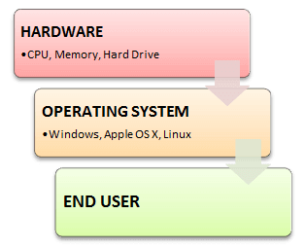

## Types of Operating System (OS)

Following are the popular types of Operating System:

* Batch Operating System
* Multitasking/Time Sharing OS
* Multiprocessing OS
* Real Time OS
* Distributed OS
* Network OS
* Mobile OS

**Features of Operating System (OS)**

Here is a list important features of OS:

* Protected and supervisor mode
* Allows disk access and file systems Device drivers Networking Security
* Program Execution
* Memory management Virtual Memory Multitasking
* Handling I/O operations
* Manipulation of the file system
* Error Detection and handling
* Resource allocation
* Information and Resource Protection

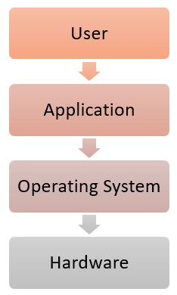

**Advantage of using Operating System**

* Allows you to hide details of hardware by creating an abstraction
* Easy to use with a GUI
* Offers an environment in which a user may execute programs/applications
* The operating system must make sure that the computer system convenient to use
* Operating System acts as an intermediary among applications and the hardware components
* It provides the computer system resources with easy to use format
* Acts as an intermediator between all hardware's and software's of the system

**Disadvantages of using Operating System**

* If any issue occurs in OS, you may lose all the contents which have been stored in your system
* Operating system's software is quite expensive for small size organization which adds burden on them. Example Windows
* It is never entirely secure as a threat can occur at any time

**What is Kernel in Operating System?**

The kernel is the central component of a computer operating systems. The only job performed by the kernel is to the manage the communication between the software and the hardware. A Kernel is at the nucleus of a computer. It makes the communication between the hardware and software possible. While the Kernel is the innermost part of an operating system, a shell is the outermost one.